Community Online Course

It is no overstatement to claim that record keepers make history. Those that manage these records are the curators of tomorrow’s history.

In the ‘olden’ days it used to be quite simple…generally there were a whole heap of letters sent or received, written quite elegantly and with the Queens English of course, and these were registered in some equally beautiful calf skin bound leather volumes manufactured by a character from Dickens.

The letters, and whatever else that had to be documented, came on paper. There was lots of paper, as there was very little else…maybe vellum, leather, but certainly lots of paper.

The records created in this relatively stable format had a shelf life bearing pretty good odds. And even better, you didn’t need anything else other than a magnifying glass, at the worst of times, to be able to read them. One hundred, two hundred years later, that’s probably, still all you need.

The greatest threat to these paper records was fire and flood well into the 20th century.

Within the past 2 decades, the story has changed dramatically. A significant amount of us have broadband in our homes, and an even larger amount has access to the Internet on our phones (even though half of us don’t know how to use it!). The point is, at the flick of a switch we can be inundated with information from a variety of sources and in a variety of formats.

Information is at our fingertips, we want it all and we want it now and digital access to records is increasingly becoming commonplace.

We will be taking a look at the types of digital records government creates and how you can access these types of records.

We will start by taking a look at the creation of records and the definitions of records including electronic and digital records.

The Creation of Records

Every day individuals within the private and public sectors create and generate various types of documentation, which contribute not only to the daily operating practices of the business, but also the recording of our social interactions. Some of these documents contain vital parts of information about the daily activities of the business. Government agencies within Australia have an obligation, generally under legislation to create and store these records whether they be in digital or paper format.

The creation of records supports 3 major purposes.
- Administration
- Legal
- Historic

Administration
Records serve as an administration function within private and public sectors by providing formal documentation of activities that have been conducted. They capture the internal information that can contribute to building towards the agency’s knowledge base. Records assist internal customers on what the day-to-day operations of the agency are. They provide a level of transparency to external customers if administrative procedures or decisions are questioned.

Legal
They can serve as evidence that can be used in a court of law. They show how decisions were made and track the course of events that led up to the final decision.

Historic
This can be extremely valuable to external customers. Records can have a significant historical value if they have been captured and stored correctly. As an example, the State Records of South Australia Repository currently has over 75 kilometres of permanent records and is growing on a daily basis! Some of these records date back to the early days of colonisation of South Australia and can be viewed by the public.

Increasingly records are being created in digital format and as such need to be managed appropriately. This is something that government agencies need to handle. How are these records created and how can they be stored so that they can be accessed in the future.

What is an Electronic Record
A record created, communicated and/or maintained by means of electronic equipment. Although this term can refer to analogue materials (eg. videotapes), it generally refers to records held in digital form on magnetic or optical computer storage media.

(Adapted from Standards Australia AS 4390, Part 1, Clause 4.13; Kennedy, J,
and Schauder, C, Records Management: A Guide to Corporate Recordkeeping,2nd edition, Longmans, Melbourne, 1988, p. 293.)

What is a Digital Record
A record created and/or maintained by means of digital computer technology. Includes records that are ‘born digital’ or have undergone conversion from a non-digital format. Digital records are a subset of electronic records.

(National Archives of Australia, Guidelines for Implementing the Functional Specifications for Recordkeeping Functionality in Business Information Systems Software Exposure draft, 2006, p.107, http://www.naa.gov.au/records-management/publications/BIS-guidelines.aspx

What is digital archiving?

Digital archiving is the preservation and maintenance of digital records that have been either created in an electronic format or migrated into an electronic document.

The Changing Environment
Archives are no longer “institutions” that collect manuscripts for purely research purposes. The information being retained and preserved by archives has changed, the format of this information has changed, the people accessing these objects is changing, even the general understanding of what constitutes an archive has changed.

More and more people now have access to the Internet and in the years to come this may result in an increased demand for access online to records held in archives.

As the Consultative Committee for Space Data Systems (CCSDS) state in their Reference Model for an Open Archival Information System (Blue Book, January 2008, Page 2-1):

The term ‘archive’ has come to be used to refer to a wide variety of storage and preservation functions and systems. Traditional archives are understood as facilities or organizations that preserve records, originally generated by or for a government organization, institution, or corporation, for access by public or private communities. The archive accomplishes this task by taking ownership of the records, ensuring that they are understandable to the accessing community, and managing them so as to preserve their information content and authenticity. Historically, these records have been in such forms as books, papers, maps, photographs, and film, which can be read directly by humans, or read with the aid of simple optical magnification and scanning aids. The major focus for preserving this information has been to ensure that they are on media with long-term stability and that access to this media is carefully controlled.

The explosive growth of information in digital forms has posed a severe challenge not only for traditional archives and their information providers, but also for many other organizations in the government, commercial and non-profit sectors. These organizations are finding, or will find, that they need to take on the information preservation functions typically associated with traditional archives because digital information is easily lost or corrupted. The pace of technology evolution is causing some hardware and software systems to become obsolete in a matter of a few years, and these changes can put severe pressure on the ability of the related data structures or formats to continue effective representation of the full information desired. Because much of the supporting information necessary to preserve this information is more easily available or only available at the time when the original information is produced, these organizations need to be active participants in the long-term preservation effort, and they need to follow the principles espoused in this OAIS reference model to ensure that the information can be preserved for the Long Term. Participation in these efforts will minimize the lifecycle costs and enable effective long-term preservation of the information.

There are many archives, government agencies and private organisations that can provide you with access to a digital archive, often through the Internet.

As an example the following agencies provide online access to digital records:

The National Archives (UK)

The National Archives UK have digital records online and various records can be accessed via their website Electronic Records Online.

The National Archives UK state that “this service holds electronic records from United Kingdom government department, including the records of a number of high-profile public inquiries, departmental websites, and the records of parliamentary committees and royal commissions. These records can exist in an enormous variety of formats including word-processed documents, applications, databases, virtual-reality models and audio-visual material.”

Records can be found online by either using the search or browse option, both of which are explained from their website which can be seen below http://www.nationalarchives.gov.uk/ero/

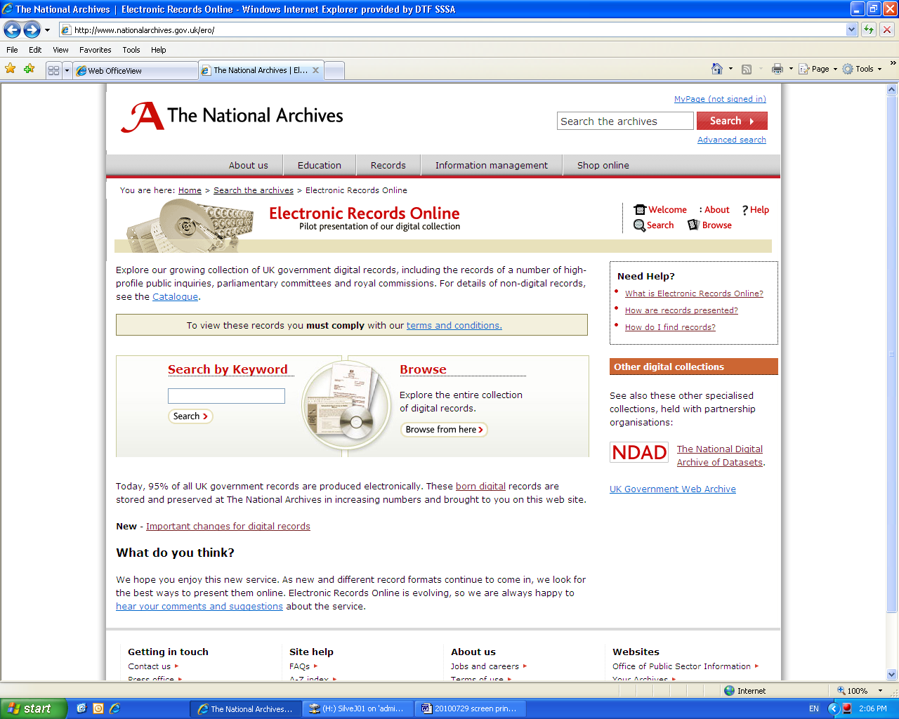

How National Archives of Australia (NAA) preserves digital records of Australian Government agencies

The following information has been taken for the NAA’s website and explains how they preserve digital records of the Federal Government:

The National Archives selects, maintains and preserves Australian Government records of enduring value, and makes them available for public access under the conditions specified within the Archives Act 1983.

In a rapidly changing digital environment, meeting this responsibility is a real challenge. Hardware and software obsolescence requires the National Archives to intervene actively to maintain digital records and provide access to them long after their creation.

Consider the type and volume of records government agencies create in their day-to-day operations. The Department of Finance and Administration, for example, generates numerous records each day, dealing with Budget matters, financial initiatives and reviews, and financial advice and training for all of government. Some of these records are paper but many are digital. The digital records comprise many formats: word-processing documents, spreadsheets, emails, images and so on.

Some 18 Australian Government departments, with responsibility for 187 agencies, generate a vast number of records each year. Generally, no more than 5 per cent of records are deemed to be of archival significance and transferred to the National Archives for safekeeping and future access. That 5 per cent of records will eventually comprise more digital records than paper records.

http://www.naa.gov.au/records-management/secure-and-store/e-preservation/at-naa/index.aspx

Records can be found online at NAA by using their Record Search. Once you have searched or browsed for the records you are looking for they will indicate what is located there and what is digitised.

NAA Records Search Screen:

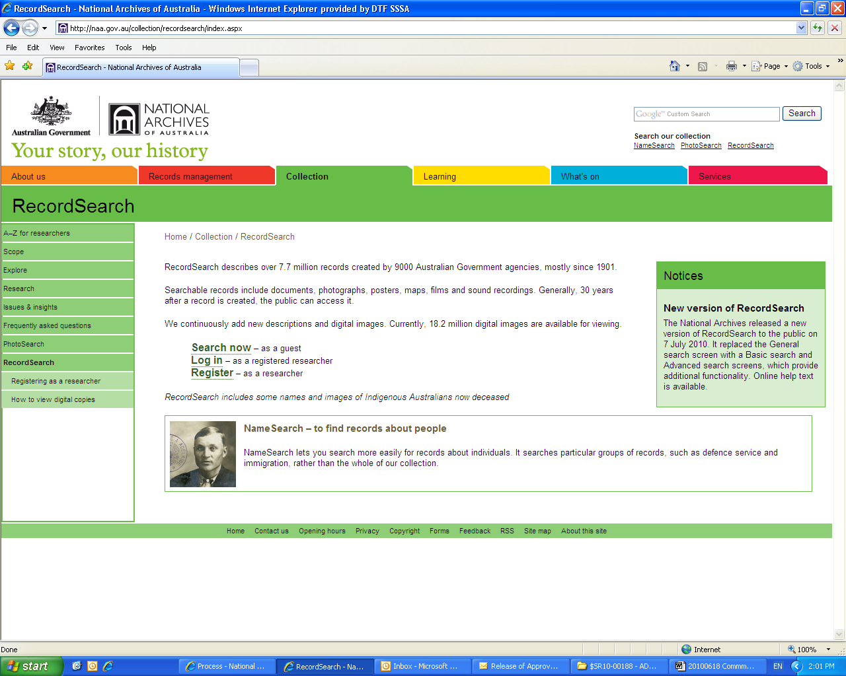
Example of digital record from NAA:

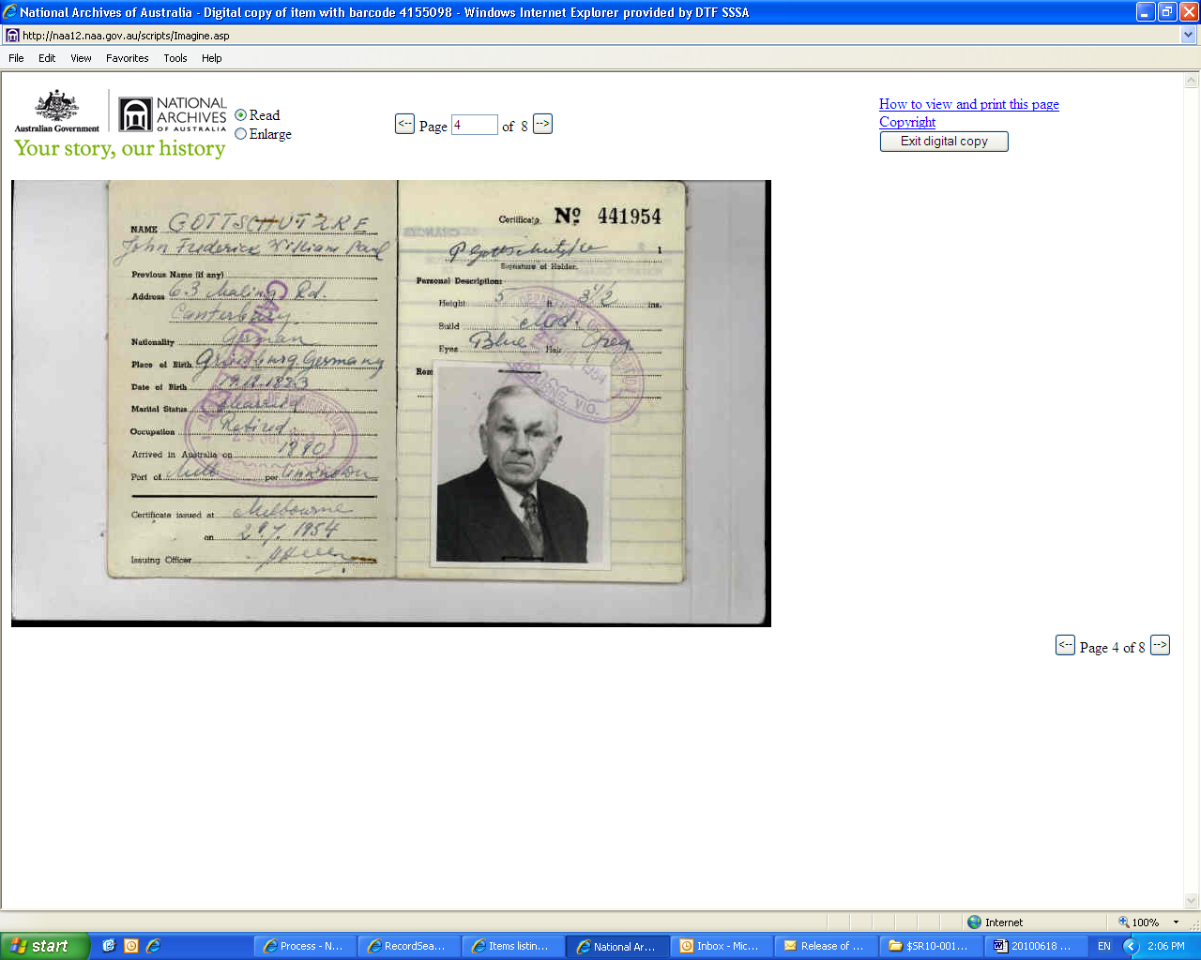

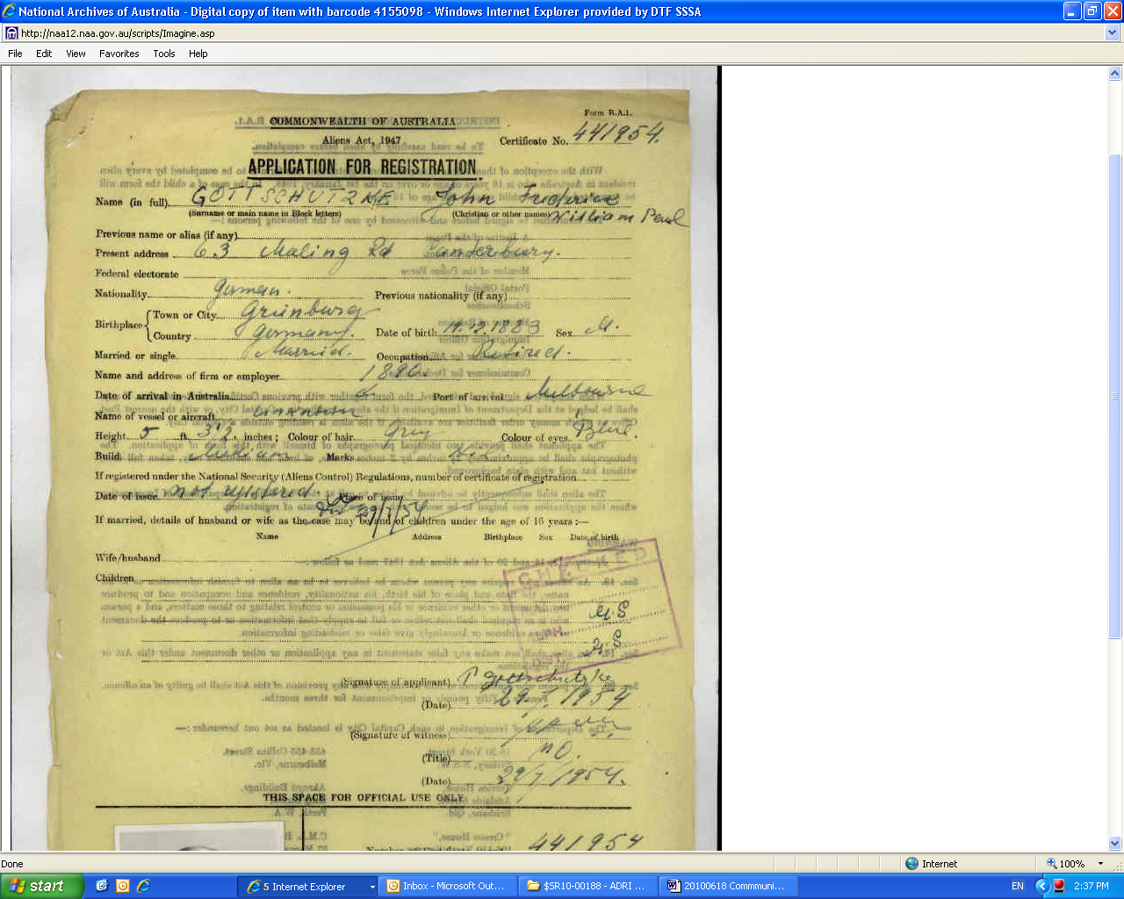
So how do you access these digital records or even know what exists?

There isn’t a list that you can find that will direct you to the information that you are looking for and where you may find it. Generally a good place to start if you are looking for digitally archived government records is your State Archives or your State Library.

Often you may find digitised records, records that were in a paper format that have been scanned and put online rather than records that were created digitally.

A list of all State Archives with links to their websites can be found below:
- National Archives of Australia - with State/Territory offices
- Archives Office of Tasmania
- Northern Territory Archives Service
- Public Record Office Victoria
- Queensland State Archives
- State Records Authority of New South Wales
- State Records of South Australia
- State Records Office of Western Australia
A list of all State Libraries with links to their websites can be found below:
- Australian Capital Territory Heritage Library
- Northern Territory Library
- State Library of New South Wales
- State Library of Queensland
- State Library of South Australia
- State Library of Tasmania
- State Library of Victoria
- State Library of Western Australia

Further Example of Digital Material

As an example the National Library of Australia, in collaboration with the Australian State and Territory libraries, began a program in March 2007 to digitise out of copyright newspapers.

In July 2008 the Australian Newspapers was released to the public. This is a free online service that enables searching of newspaper articles. The service includes newspapers published in each state and territory from the 1800s to the mid-1950s, when copyright applies. The first Australian newspaper, published in Sydney in 1803, is included in the service. By 2011 the service will compromise 40 million searchable articles.

To view and search for historical Australian Newspapers all you need to do is click on the following link http://newspapers.nla.gov.au/

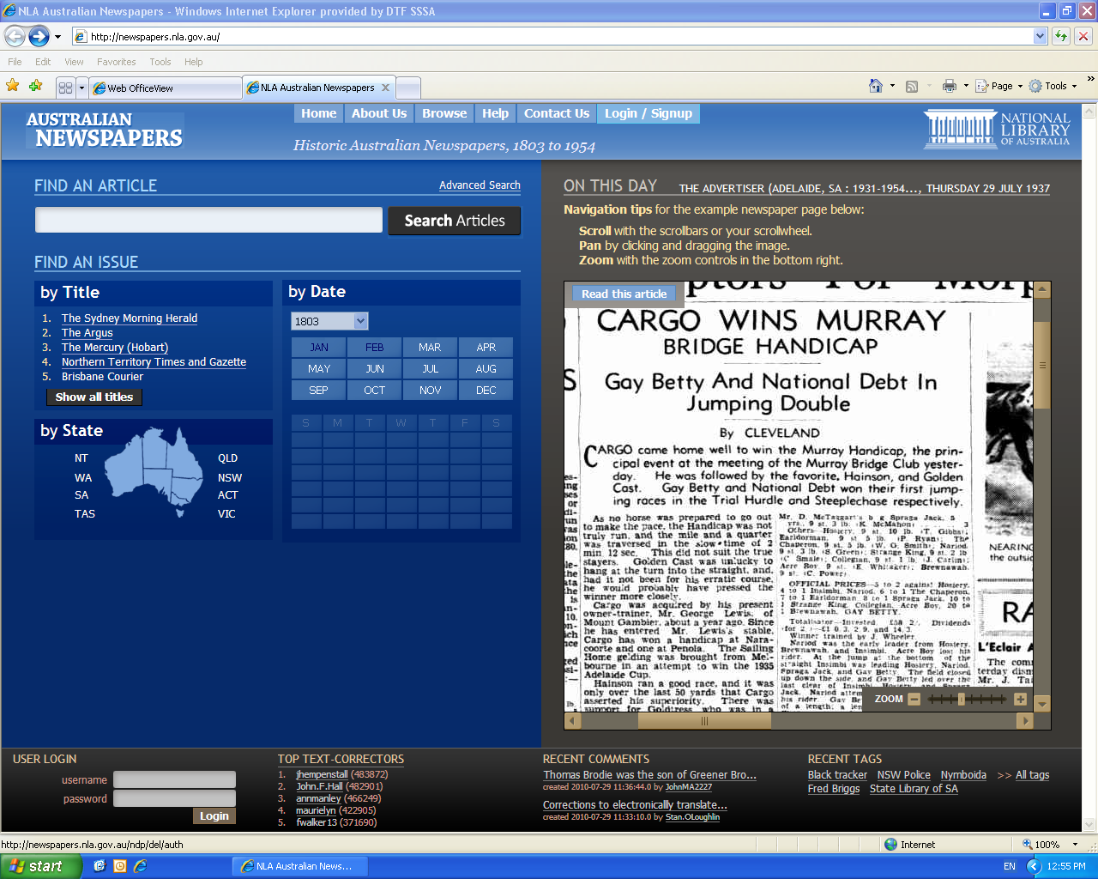

You can then search these particular newspapers by looking for an article or locating a particular issue, by title, state or date.

Australian Newspapers have provided a Frequently asked questions link in order to help you in your search:
http://www.nla.gov.au/ndp/contact_us/faq.html

If you would like to view current newspapers many newspapers are putting their current issues online, some you may need to access via a subscription.

Another example of digital ‘records’ not necessarily related to archives is the availability of books online. Once again, like the newspapers mentioned above, books that are out of copyright can be accessed for free at http://www.gutenberg.org/wiki/Main_Page.

If you were interested in current book titles Amazon, Borders and Angus and Robertson as an example have also digitised certain books and these can be purchased at the according sites.

Borders Online books:
http://www.borders.com.au/ebooks/ebooks/45/

Angus and Robertson Online books (e-books):
An eBook is an electronic or digital version of a printed book.
http://www.angusrobertson.com.au/ebooks/ebooks/45/

